List of items to discuss

1. Change *Diplocardia* sp. in the figures to *Diplocardia caroliniana*.

> GC: Yup, I’ve updated the species name.

1. Should we have unstandardized stable isotope scatterplots in the appendix?

> GC: I think it is not necessary to do so. Since the main focus of this paper is idea/concept rather than methodology, I feel that it doesn’t really matter that much whether the unstandardized and standardized figures differ a lot from each other or not. The key point is that we can justify our way of standardization.

Still, I can prepare the unstandardized figures at hand just in case reviewers want to see them.

1. Assignment of BDTR sites: should we treat plot 16/17, 28/30/37, 39/40, and 68/70/71/72 as four separate sites rather than the original two (39/40 and the rest)?

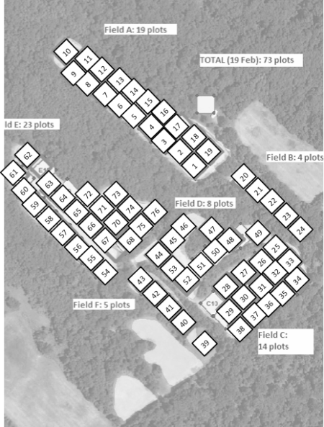

> GC:

Reason to have four sites:

* Since the three blocks (16/17, 28/30/37, and 68/70/71/72) are spatially separate from each other, they could differ in their vegetation/soil profile even though they had similar land use history. The difference might not be that obvious (compared with plot 39 and 40), but still it would be good to have finer resolution of the sites, which can probably reduce the noise or variations among them.

Reason not to have four sites:

* If the three blocks were similar in terms of vegetation/soil profile, then even though they are spatially separated, we can still treat them as a single site. After all, there is no absolute definition of a “site” right? It can be as small as a single plot or as large as the whole research area, and I think what really matters is the purpose of the study and research questions we ask.
* Another potential downside of having four sites is that we may suffer from low sample size for each site. The niche metrics are still computable, but the uncertainty might increase. Just not sure how this will turn out.

Satellite images of the BiodiversiTREE research area (1022 Cumberstone Road, Harwood, MD): trees were planted late in 2012; samples were taken in 2013 spring

https://treedivnet.ugent.be/ExpBiodiversiTREE.html

|  |  |
| --- | --- |
| 2005 | 2010 |
| 2011 | 2014 |
| 2019 | 2021 |

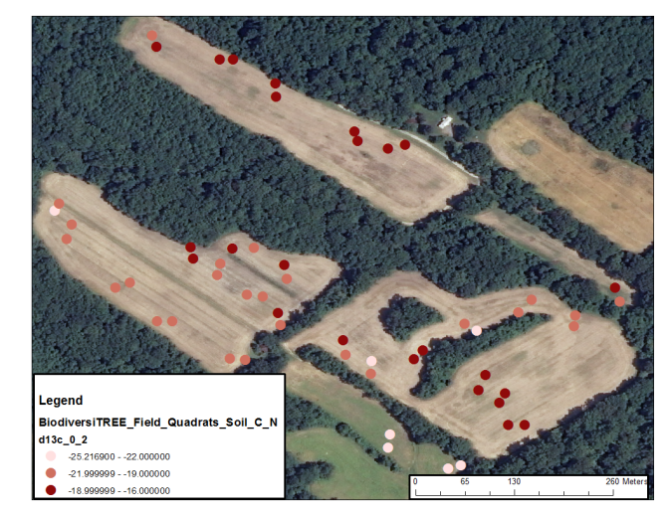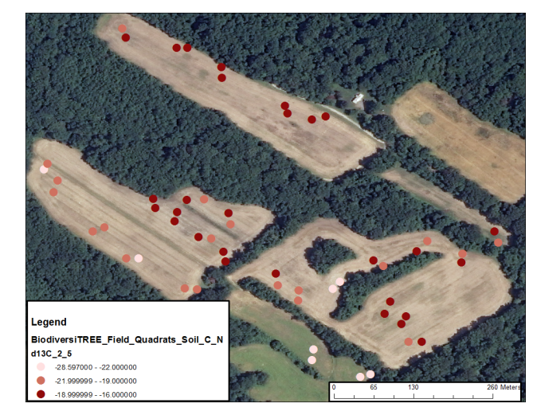

* Plots 39 and 40 do look different superficially before 2012.
* Plots 39 and 40 had highest C3 signals in surface soil (more negative d13C values). The remaining plots were relatively similar in their d13C.
* The range of d13C of soil expands from 4.2 to 8.6 per mil when plots 39 and 40 are included vs. not included.
* The carbon signal were obviously different between plots 39 and 40 and the rest.

One possible workaround is that we can statistically compare the soil isotope signatures of the four sites. If the three sites (excluding plots 39 and 40) are not isotopically different from each other but different from plots 39 and 40, then we are good to go and we can provide this information to back up our site assignment. If they do differ a lot, then we may want to decide whether to treat them individually or not. And if really, we are going to do so, then I feel we should be careful when interpreting the results because we are now delimiting the sites “statistically” rather than based on our prior knowledge of their habitat features.

Permutation test for pairwise comparisons of soil d13C and d15N between the four blocks in BDTR research area (Block 1: Plot 16/17; Block2: Plot 28/30/37; Block3: Plot 68/70/71/72; Block4: Plot39/40):

|  |  |  |  |  |
| --- | --- | --- | --- | --- |
| Soil depth | Block pair | | d13C_Pval | d15N_ Pval |
| 0-2 | Block1 | Block2 | 0.312 | 0.195 |
|  | Block1 | Block4 | 0.027 | 0.192 |
|  | Block1 | Block3 | 0.157 | 0.314 |
|  | Block2 | Block4 | 0.037 | 0.417 |
|  | Block2 | Block3 | 0.462 | 0.138 |
|  | Block4 | Block3 | 0.008 | 0.143 |
| 2-5 | Block1 | Block2 | 0.269 | 0.797 |
|  | Block1 | Block4 | 0.024 | 0.260 |
|  | Block1 | Block3 | 0.045 | 0.311 |
|  | Block2 | Block4 | 0.042 | 0.187 |
|  | Block2 | Block3 | 0.576 | 0.213 |
|  | Block4 | Block3 | 0.024 | 0.229 |

> Block 4 (Plot 39/40) is different from the other three blocks in terms of d13C signature.

As mentioned, any approach (one, two, or four sites) is fine, as long as we can justify it, and I agree that it should not make a huge difference in the results.

1. A table version of the percentage overlapping SEAb in the appendix.

> GC: Yup, I’ve made the tables for each study site.